Programming for the Java 2 Platform, Enterprise Edition
The JavaTM 2 Platform, Enterprise Edition (J2EETM) is an architecture for a Java development platform for distributed enterprise applications. It was developed by Sun Microsystems, with input from the development community, including Borland. J2EE platform products, such as the Borland Enterprise Server, offer the developer the capability of building applications with these benefits:
- Reliability and scalability, so business transactions are processed quickly and accurately.
- Excellent security to protect users' privacy and the integrity of the enterprise's data.
- Ready availability, to meet the increasing demands of the global business environment.
JBuilder is a Java integrated development environment that, when coupled with a supported application server from companies such as Borland, BEA, IBM, and JBoss greatly simplifies and speeds the development of J2EE applications.

Why are J2EE applications desirable?
In the early 1990s, information systems frequently used a client-server architecture. The user interface to the application usually ran on a desktop computer. This was the client tier. The enterprise data being accessed by the client resided in a database and was "served up" by a server. This approach initially promised improved scalability and functionality.
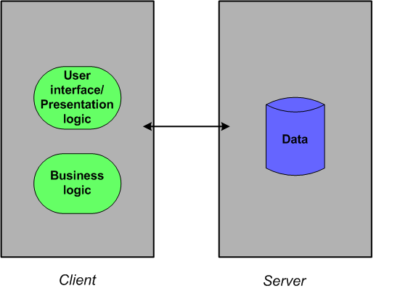
Through hard experience, however, the development community learned that building and maintaining a flexible distributed system is very difficult using the client-server model. For example, the business logic of the application was in the client application. Every time that logic needed modification, the revised application had to be installed on every client machine in the enterprise. Maintenance became a nightmare. These applications also had to manage transactions, be concerned with security, and process the data efficiently, all the while presenting an attractive, easy-to-understand interface to its users. Few developers have talents in all these areas. While a client-server architecture might be adequate for some environments, most of today's global companies demand considerably more than the client-server model can deliver.
Once the limitations of the client-server approach became apparent, the development community began seeking a better way. The result is the multi-tier model.
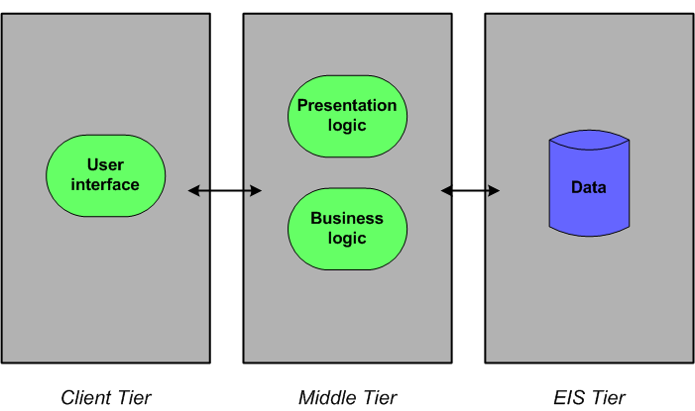
In the multi-tier model, the logic involved in presenting the user interface of the application to the user lives on the middle tier. The business logic is now on the middle tier also. When changes are needed, they can be updated in one place instead of on each client machine.
This expanded diagram shows you the various components you might find running on the various tiers:
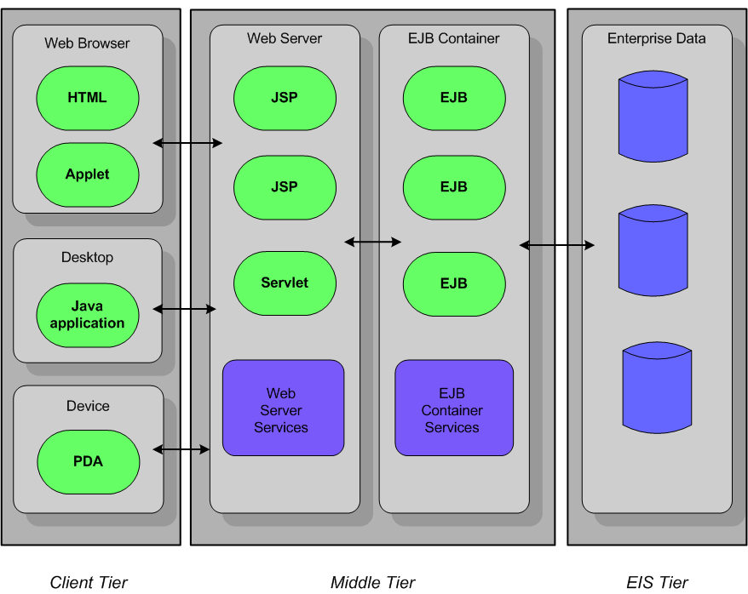
The client in a J2EE application can be an HTML page or applet running in a browser, a Java application on a desktop machine, or even a Java client on some portable device, such as a personal digital assistant (PDA) or cell phone.
The middle-tier can have JavaServer PagesTM or servlets running on a web server. These elements usually make up the server-side presentation logic. An EJB container provides a runtime environment for Enterprise JavaBeansTM, which contain the business logic of application. Both a web server and an Enterprise JavaBeans (EJB) container provide services to the components that run on them. Because these services are always available, programmers don't have to include them in the components they write.
The Enterprise Information System (EIS) tier is a repository for the enterprise's data. Usually it consists of the data in a relational database system.
Few J2EE applications have all of these components. They can be mixed and matched in very flexible ways to meet the needs of the enterprise. See "Creating applications with J2EE technologies" for more on this topic.

Benefits of the multi-tier model
The multi-tier approach adopted by the J2EE platform has several benefits:
- It reduces the complexity of distributed development with a simplified architecture and the sharing of the work load among roles.
The business logic of the application runs in the middle tier inside an Enterprise JavaBean (EJB) container and/or on a web server. These containers and servers can handle many of the difficult tasks for developers. For example, an EJB container can handle transactions, instance pooling, and data persistence without requiring the EJB programmer to write the logic to perform these tasks. A web server can create and pool instances of servlet classes and handle multiple threads and socket connections. Instead of writing the code to do these things, a member of the development team specifies the desired behavior at deployment time.
Members of the development team play different roles. Each is a specialist in one or more areas. For example, the content of an HTML page or stylesheet would likely be created by a graphic designer or webmaster. A senior developer might be responsible for the business logic of the application encapsulated within Enterprise JavaBean components. A web developer might develop the user interface and presentation logic using JavaServer Pages (JSPs) and servlets. An application assembler takes the various components of the application and puts it all together, often creating an Enterprise Archive (EAR) file and creating the deployment descriptor that explains how the application is to be deployed. The application deployer and administrator deploy the application. By partitioning the work this way, each step of the development/deployment process is handled by someone skilled in their area while no one has to be an expert in every area.
- It is highly scalable, allowing the development of systems to meet many different needs that can change quickly.
When demands on the system increase, the logic can be updated easily in one place on the middle tier without having to load new logic on every client machine.
- New applications can integrate well with existing information systems.
JDBC, a J2EE technology, is a Java API to SQL databases, permitting the access to any type of tabular data that might exist in the enterprise. The Java Naming and Directory Interface (JNDI) allows applications that use Java technology to access enterprise naming and directory services. The J2EE Connector architecture gives Java applications connections to heterogeneous legacy systems. The Java Message Service (JMS) is the Java API for sending and receiving messages though enterprise messaging systems. CORBA services are called using JavaIDL.
- Security is enhanced.
J2EE technologies are designed with security in mind. For example, only users in assigned roles can access certain methods in enterprise beans. Who can access these methods isn't coded in the enterprise beans themselves. Instead this information is set in the enterprise beans' deployment descriptors, which are used by the deployer to establish their behavior after they are deployed. This type of security is called declarative security.
For complex security requirements, however, J2EE also allows programmable security. In these cases, the security logic is placed within the code itself.
- Developers can choose from a variety of development tools, servers, and components to develop the applications they need.
The development team can select the solutions that are best for their needs, without becoming locked into the offerings of a single vendor.

How JBuilder can help
JBuilder Enterprise Edition has many features to help your team develop J2EE applications. These are the technologies JBuilder has to help you develop the client tier:

Client tier technologies
- Applets
Applets are a special kind of Java application that are downloaded and run by a web browser on a client machine. To begin developing an applet in JBuilder, start with the Applet wizard. For information about working with applets, see "Working with applets" in Web Application Developer's Guide.
- Java user interface applications
JBuilder has several features that can help you develop an application that runs on a client machine. Begin a Java application using the Application wizard. Continue designing your user interface by using JBuilder's UI designer. You create your UI by adding UI components from JBuilder's component palette. For information on working with JBuilder's UI designer, see "Visual design in JBuilder" in Designing Applications with JBuilder.
If you want to create your own JavaBean components to use in your user interface, BeansExpress can simplify the task for you. For information about using BeansExpress, see "Creating JavaBeans with BeansExpress" in Building Applications with JBuilder. JBuilder's DataExpress components for enterprise beans make it easier for you to build client applications using database-aware visual components such as dbSwing or InternetBeans Express. For more information about DataExpress for EJB, see "Using the DataExpress for Enterprise JavaBeans components."
Both a web server and/or an EJB container can run on the middle tier. JBuilder ships with Tomcat, a servlet container that can be used as a web server, and with the Borland Enterprise Server 5.2.1, which contains the EJB container. You can build applications for these servers or you can set up JBuilder to enable you to develop applications for BEA WebLogic 6.x, 7.x, and 8.1, IBM WebSphere 4.0 and 5.0, Sun-Netscape iPlanet 6.0 and 6.5, and Sybase 4.1 and 4.2.

Middle-tier technologies
These are the middle-tier J2EE technologies that use a web server:
- Servlets
A servlet is a server-side Java application that can process requests from clients. The servlet responds to the request by generating dynamic output that is sent back to the client. You can begin developing servlets with JBuilder's Servlet wizard. To find out more about servlets and developing them, see "Working with servlets" in Web Application Developer's Guide.
- JavaServer Pages (JSPs)
An extension of servlet technology, JSPs offer a simplified way to develop servlets. Like servlets, they generate dynamic output that is sent back to the client's web browser. Begin developing JSPs with JBuilder's JavaServer Page wizard. To find out more about JSPs and developing them, see "JavaServer Pages (JSP)" in Web Application Developer's Guide.
InternetBeans Express is a component library that supplements the servlet and JSP technology available in JBuilder. This library makes it easy to present and manipulate data from a database so you can build data-aware servlets and JSPs. For information about InternetBeans Express, see "Using InternetBeans Express" in the Web Application Developer's Guide.
This is the middle-tier J2EE technology that uses an EJB container:
- Enterprise JavaBeans (EJBs)
Enterprise JavaBeans are server-side components that contain the business logic of the application. JBuilder assists you in building EJB 1.x and EJB 2.0 components. Start building enterprise beans by using the EJB wizards on the Enterprise page of the object gallery (File|New|Enterprise). For building EJB 2.0 components, JBuilder offers the EJB Designer, a Two-Way ToolTM that allows you to design your beans visually all the while keeping your code, deployment descriptors, and design synchronized. For more information about building, testing, and deploying enterprise beans, see "An introduction to EJB development."
As you create your enterprise beans, JBuilder is building your EJB deployment descriptors. You can use JBuilder's EJB DD Editor to modify them as you wish. For more information about the EJB DD Editor see "Editing J2EE deployment descriptors" in this book and "Editing EJB deployment descriptors" in the Developing Applications with Enterprise JavaBeans book.
All the web application components and enterprise bean components can be combined and delivered in an application module. JBuilder has an Application Module wizard. For more information, see "Creating an application module" in the "Deploying enterprise beans" chapter of the Developing Applications with Enterprise JavaBeans book.

Other J2EE technologies
While not confined to a particular architectural tier, these technologies are enablers that make things work:
- Java Database Connectivity (JDBC)
JDBC is the standard used to access your database on the Enterprise Information Systems (EIS) tier. It defines a Java API you use to write SQL statements that are sent to your database.
JBuilder includes DataExpress, a component library for accessing data in your database. It connects your application to your database using JDBC drivers.
JBuilder also includes JDataStore, an all-Java embedded database and component library. You access JDataStore using JDBC.
Entity beans that access rows in your database, also connect to your data using JDBC.
- Java Message Service (JMS)
JMS is an enterprise messaging service that routes messages between components and processes in a distributed application.
The Borland Enterprise Server includes SonicMQ, a JMS implementation. Also JBuilder supports EJB 2.0 components, which include message-driven beans. Message-driven beans integrate JMS into enterprise beans. JBuilder also includes a JMS wizard. See "Creating JMS producers and consumers" for information on creating classes and applications that can create and consume JMS messages.
- Java Naming and Directory Interface (JNDI)
All J2EE servers use JNDI, a Java naming service used to locate distributed objects.
- Extensible Markup Language (XML)
Although not really a J2EE technology, XML is widely used by J2EE technologies. For example, web components and enterprise beans have their deployment descriptors written in XML. These deployment descriptors describe how the components behave once they are deployed.
JBuilder has several XML features that help you accomplish common programming tasks you might encounter in your J2EE projects. For information about JBuilder's XML features, see "Introduction" in XML Application Developer's Guide.

Preparing to deploy J2EE applications
As you create and compile your web applications and enterprise beans, JBuilder can create the WAR (Web Archive) and EJB-JAR (EJB Archive) files for you automatically. You can choose to bundle the components of a J2EE application together into an EAR file. JBuilder provides an Application Module wizard to help you do this. For more information, see "Creating an application module" in Developing Applications with Enterprise JavaBeans.

Learning about J2EE
If you've read this far, you've been exposed very briefly to many concepts and, with all the acronyms to identify J2EE technologies, an alphabet soup. To develop a deeper understanding of J2EE benefits and concepts, begin your explorations on Sun's www.java.sun.com web site. This http://java.sun.com/j2ee/docs.html link takes you to Sun's J2EE documentation home page where you can find an abundance of useful information.
If you're new to J2EE programming, look at the J2EE tutorial at http://java.sun.com/j2ee/tutorial/index.html. For an in-depth discussion of J2EE programming and the recommended programming practices to use in your J2EE applications, don't miss the very detailed J2EE Blueprints, found at http://java.sun.com/j2ee/blueprints/index.html. J2EE Blueprints is an integral part of J2EE itself. You'll find it useful when you need to understand deeper concepts and are looking for the best ways to approach J2EE development. This material is also available in book form as Designing Enterprise Applications with the Java 2 Platform, Enterprise Edition written by Nicholas Kassem and the Enterprise Team of Sun. http://java.sun.com/j2ee/blueprints/aboutthebook.html links you to information about the book.
You'll find additional documentation and specifications for the various J2EE technologies on the Sun site. There are also excellent third-party books, but because J2EE is a developing product, be aware which versions of the various technologies they address.

